1. **STANDARDIZATION & NORMALIZATION**

**Problem Statement:**

Data is one of the most important assets. It is often common that data is stored in distinct systems with different formats and scales. These seemingly small differences in how the data is stored can result in misinterpretations and inconsistencies in your analytics. Inconsistency can make it impossible to deliver reliable information to management for good decision making. We have the preprocessing techniques to make the data uniform. Explore the various techniques to have reliable uniform standard data, you can go through this link:

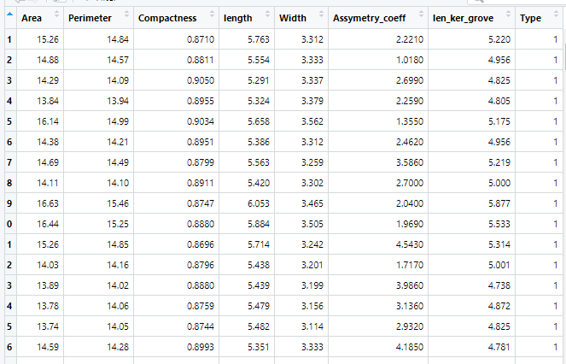

**Ans:-**

**Data types: -**

|  |  |  |  |
| --- | --- | --- | --- |
| **Name of features** | **Description** | **Type** | **Relevance** |
| Area | Area | Ratio | Relevant |
| Perimeter | Perimeter | Ratio | Relevant |
| Compactness | Compactness | Ratio | Relevant |
| length | length | Ratio | Relevant |
| Width | Width | Ratio | Relevant |
| Assymetry_coeff | Assymetry_coeff | Ratio | Relevant |
| len_ker_grove | len_ker_grove | Ratio | Relevant |
| Type | Type | Ratio | Relevant |